Project Design Phase
Solution Architecture

Date | 15 February 2025
Team ID | LTVIP2026TMIDS65742
Project Name | FlightFinder: Navigating Your Air Travel Options
Maximum Marks | 4 Marks

Solution Architecture:
Solution architecture is a complex process – with many sub-processes – that bridges the gap between business problems and technology solutions. Its goals are to:
- Find the best tech solution to solve existing business problems.
- Describe the structure, characteristics, behavior, and other aspects of the software to project stakeholders.
- Define features, development phases, and solution requirements.
- Provide specifications according to which the solution is defined, managed, and delivered.

Example - Solution Architecture Diagram:

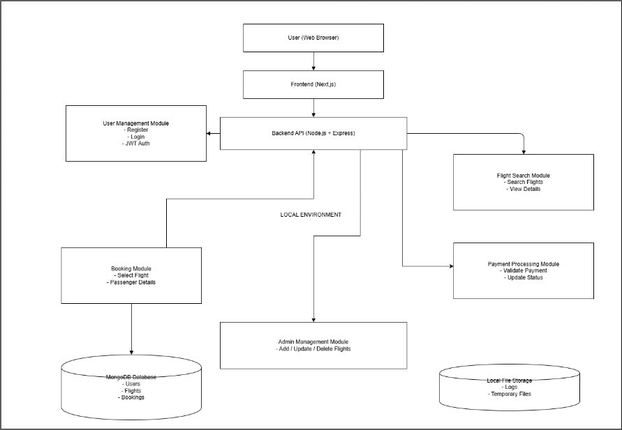
Figure 1: Architecture and data flow of the voice patient diary sample application
Reference: https://aws.amazon.com/blogs/industries/voice-applications-in-clinical-research-powered-by-ai-on-aws-part-1-architecture-and-design-considerations/
1. Overview
The Flight Booking Application follows a structured 3-Tier Architecture that bridges business requirements with a scalable technology solution. The architecture ensures secure user authentication, efficient flight search, smooth booking workflow, and reliable payment processing. The system is designed to provide a simplified booking experience while maintaining performance, scalability, and data security.
2. Architectural Layers
2.1 Presentation Layer (Frontend)
The Presentation Layer handles user interaction and is developed using Next.js. It provides functionalities such as User Registration, Login, Flight Search Interface, Booking Form, Payment Page, Booking Confirmation Page, and Admin Dashboard. The frontend communicates with backend services via REST APIs.
2.2 Application Layer (Backend / Business Logic)
The Application Layer is developed using Node.js and Express.js. It processes user requests and manages business logic including User Authentication, Flight Search Processing, Booking Management, Payment Processing, and Admin Management. This layer validates user input, performs fare calculations, updates booking status, generates PNR numbers, and integrates external APIs.
2.3 Data Layer (Database & Storage)
The Data Layer uses MongoDB for persistent data storage. It maintains collections for Users, Flights, and Bookings. This layer ensures secure storage, efficient retrieval, and data consistency.
3. External Interfaces
The system integrates with third-party services including Payment Gateway APIs (such as Razorpay or Stripe) for secure transaction processing and Email Service APIs for sending booking confirmation notifications. These integrations enhance system functionality while maintaining modularity.
4. Infrastructure Design
The application supports both Local and Cloud deployment models. In Local Deployment, the frontend and backend run on a local server with MongoDB hosted locally. In Cloud Deployment, the frontend can be deployed on Vercel, the backend on Render or similar cloud platforms, and the database on MongoDB Atlas. This design ensures scalability, availability, and flexibility.
5. Data Flow Description
Users search for flights through the frontend interface, which sends requests to the backend. The backend retrieves flight data from the database and returns matching results. After selecting a flight and entering passenger details, the backend processes payment via the Payment Gateway API. Upon successful transaction, booking details are stored in the database, a PNR is generated, and confirmation is displayed to the user.
6. Key Architectural Characteristics
The system follows a modular 3-tier architecture, uses REST API-based communication, implements secure authentication using JWT, supports cloud-ready deployment, and maintains scalable database design to handle increasing user loads.

